## Lab_Day-5 ANP-C9180 (Functions)

**Q1. Declare a div() function with two parameters. Then call the function and pass two numbers and display their division.**

**Sol:**

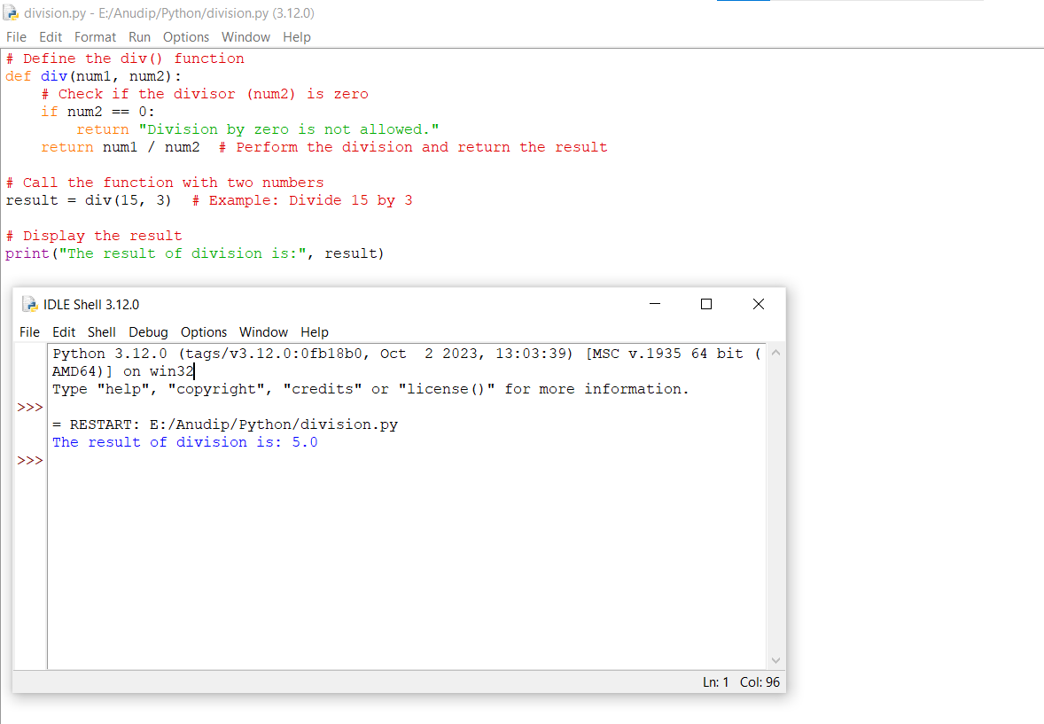

**Q2. Declare a square() function with one parameter.Then call the function and pass one number and display the square of that number .**

**Sol:**

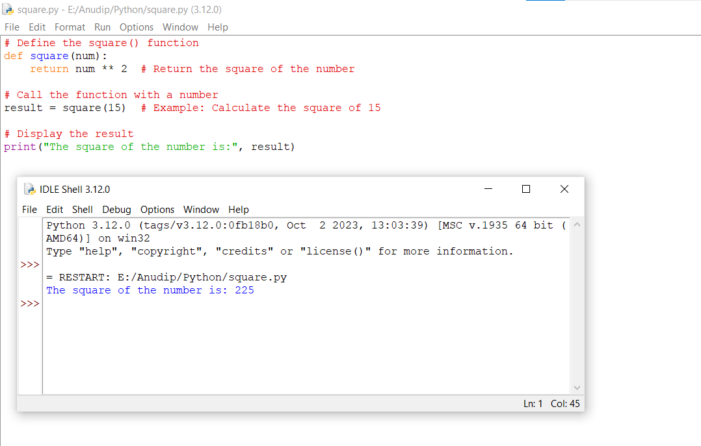

**Q3. Using max() and min() functions display the maximum and minimum of 5 random numbers.**

**Sol:**

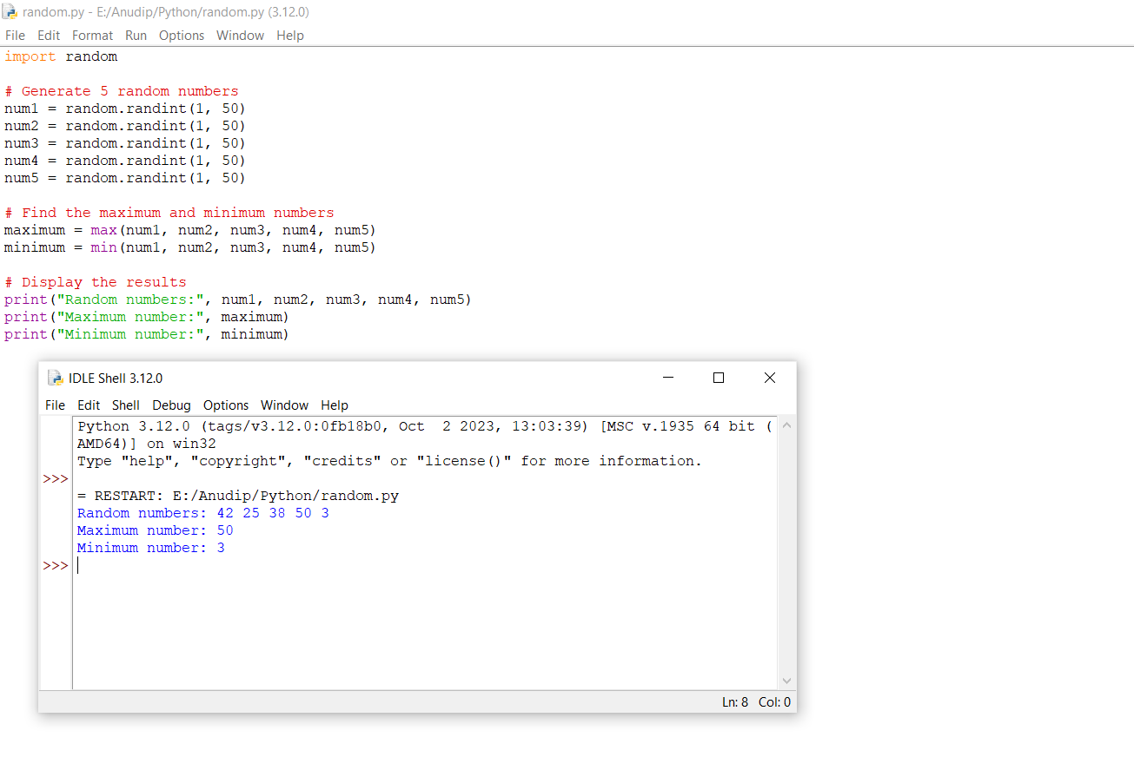

**Q4. Accept a name from the user and display that in lower case using lower() function.**

**Sol:**

